

9/6/2023

SOFRTWARE DESIGN

**HIRRA ZAHID**

# CLASS DIAGRAM

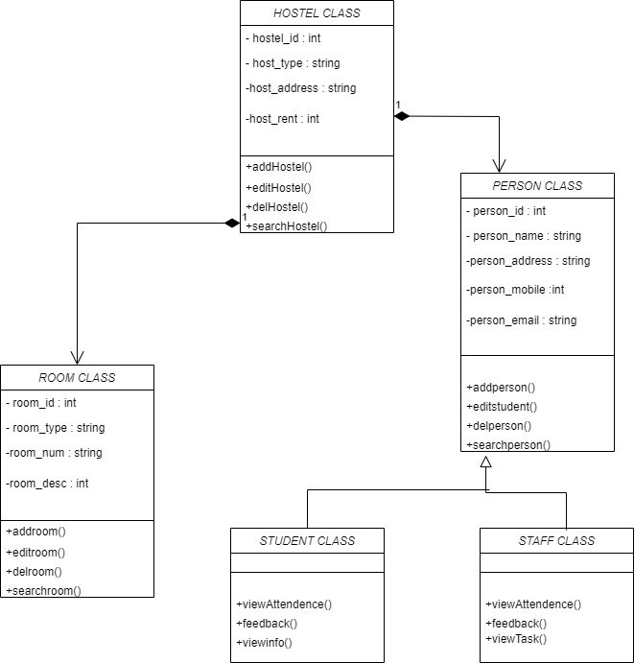

**ERD**

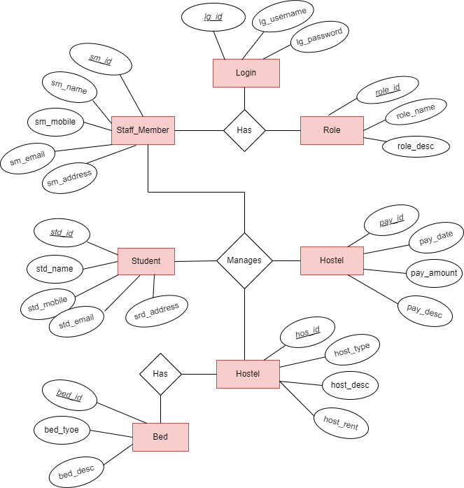

# USE CASE DIAGRAMS

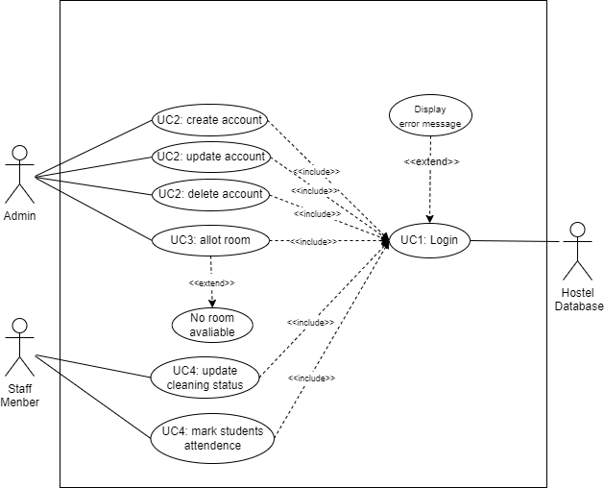

**PORTAL FUNCTIONALITY USE CASE**

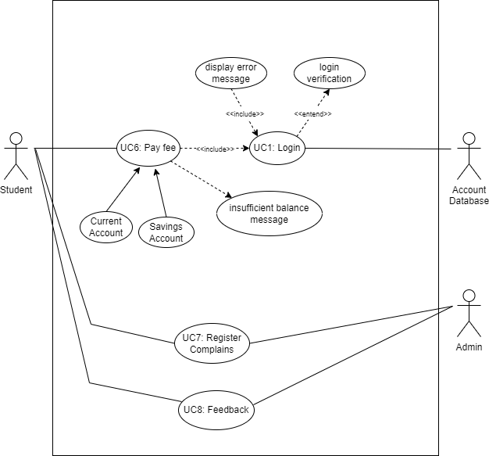

**PAYMENT USE CASE**

**ACTIVITY DIAGRAMS**

LOGIN

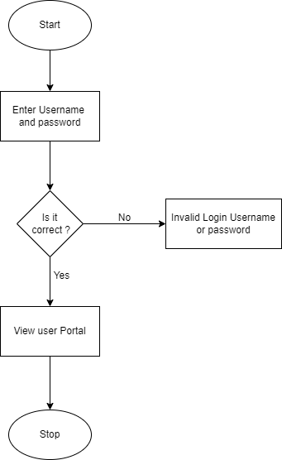

ACCOUNT HANDLING

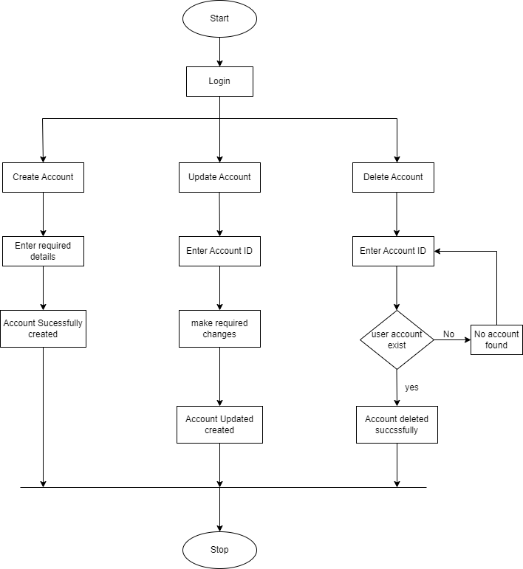

FEE PAYMENT

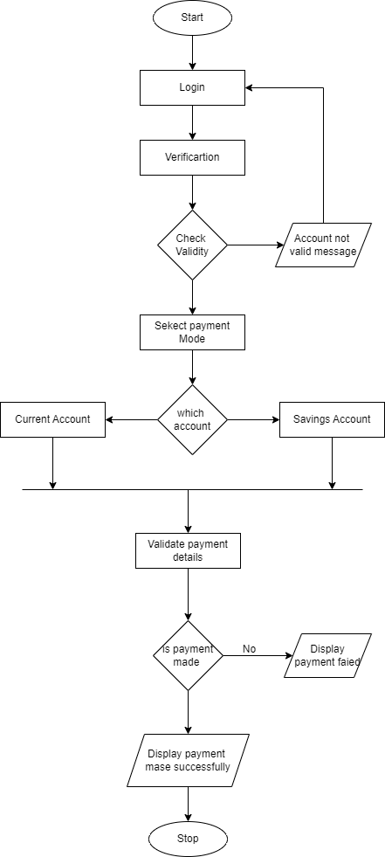

ROOM ALLOTMENT

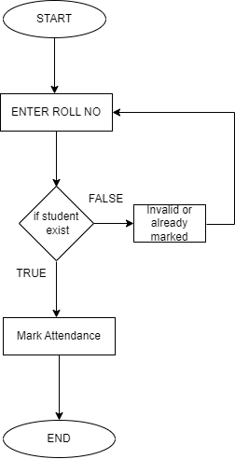

STUDENT ATTENDENCE



# SEQUENCE DIAGRAMS

LOGIN

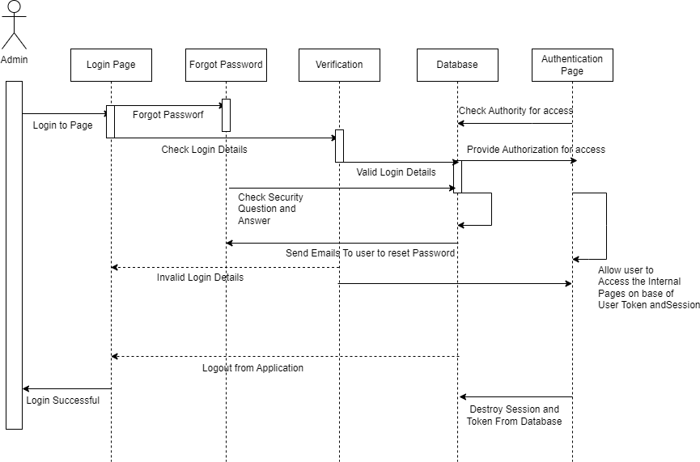

ACCOUNT HANDLING

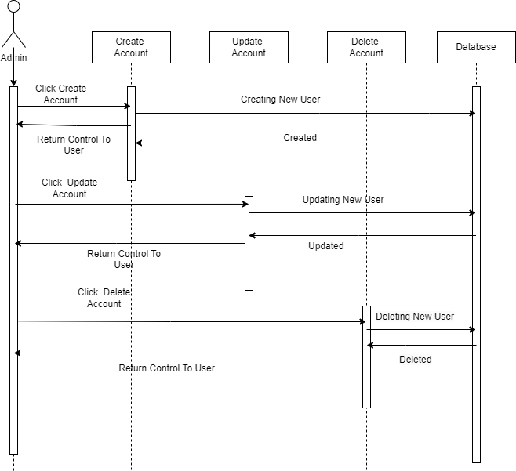

ROOM ALLOTMENT

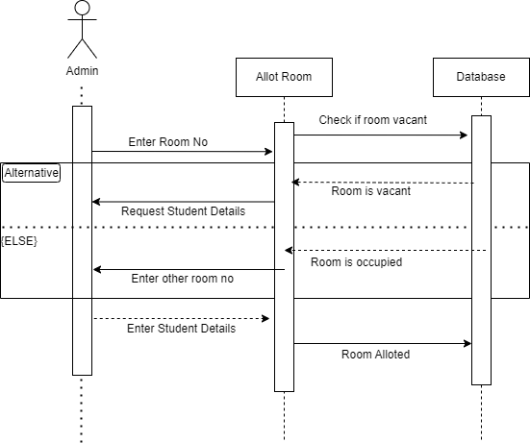

ATTENDENCE

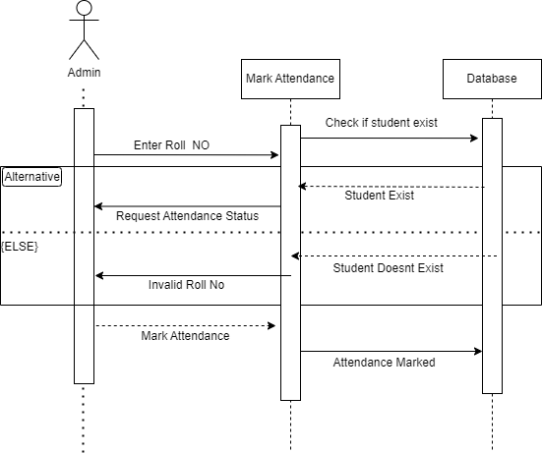

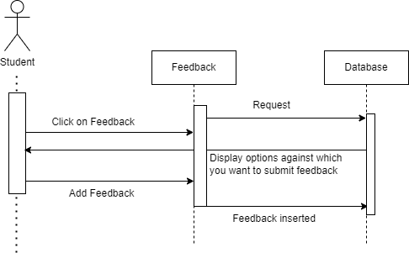STUDENT FEEDBACK

# DATA FLOW DIAGRAMS

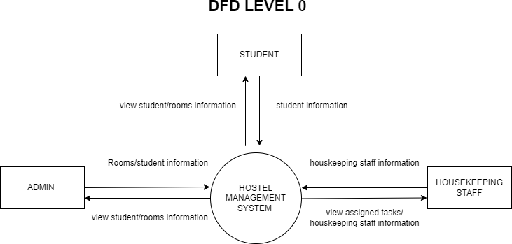

DFD LEVEL 1

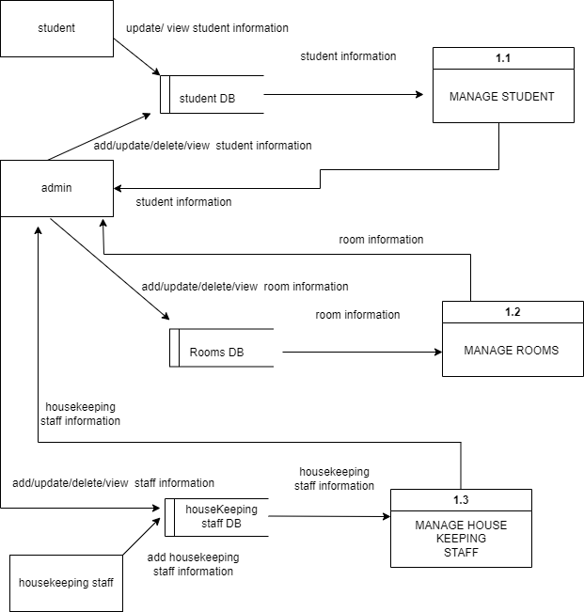

**DFD LEVEL 2**

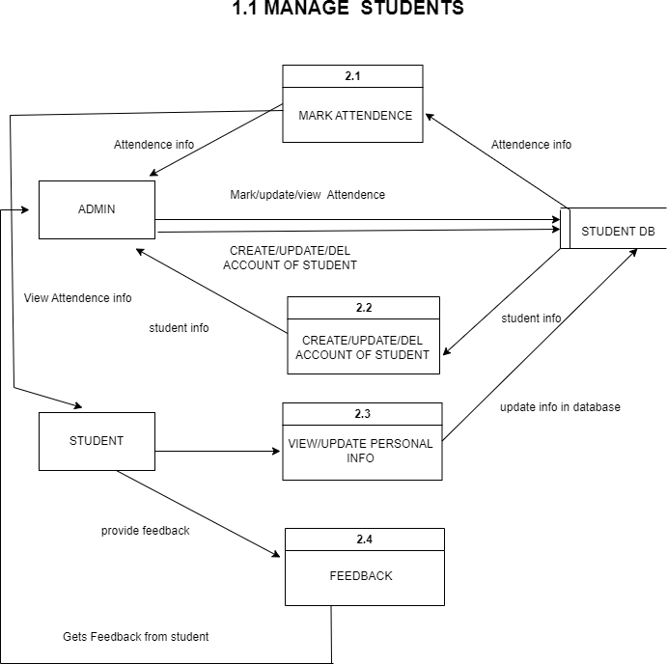

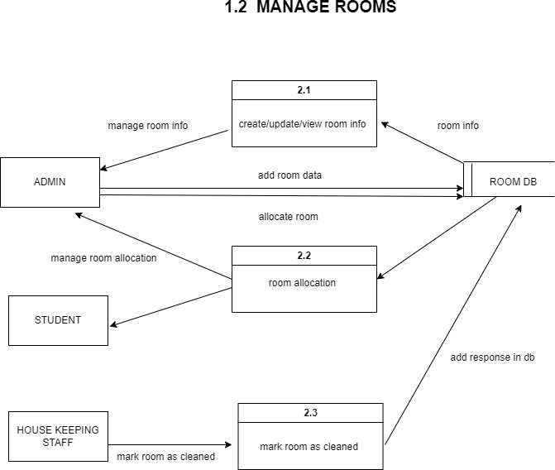

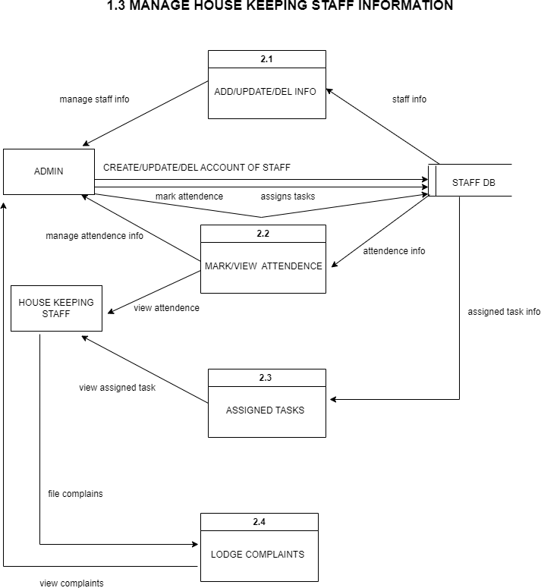

END